Query the two cities in **STATION** with the shortest and longest *CITY* names, as well as their respective lengths (i.e.: number of characters in the name). If there is more than one smallest or largest city, choose the one that comes first when ordered alphabetically.  
The **STATION** table is described as follows:

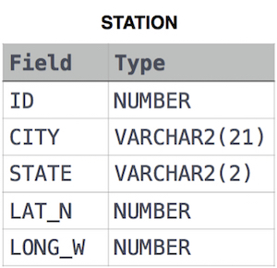

where **LAT_N** is the northern latitude and **LONG_W** is the western longitude.

**Sample Input**

For example, **CITY** has four entries: **DEF, ABC, PQRS** and **WXY**.

**Sample Output**

ABC 3

PQRS 4

**Explanation**

When ordered alphabetically, the **CITY** names are listed as **ABC, DEF, PQRS,** and **WXY**, with lengths  and . The longest name is **PQRS**, but there are  options for shortest named city. Choose **ABC**, because it comes first alphabetically.

**Note**  
You can write two separate queries to get the desired output. It need not be a single query.

Ans:

select CITY,length(CITY) from STATION order by length(CITY) asc,CITY limit 1;

select CITY,length(CITY) from STATION order by length(CITY) desc,CITY limit 1;